ESE 358 Project 1

Kyle Lin

SBU ID: 114977308

- Read an RGB image (8 bits/pixel) in JPEG format. Call this image A. The size of A should be 512x512. Display image A at runtime.
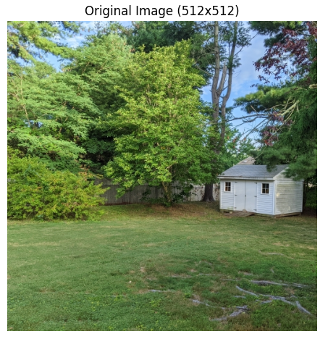

if len(sys.argv) >= 2:
img_path = sys.argv[1]
else:
img_path = input("Enter path to image file: ").strip()
if not os.path.isfile(img_path):
print(f"File not found: {img_path}")
return

# Load and display
A = load_rgb_512(img_path)
save_and_show_rgb(A, "Original Image (512x512)", os.path.join(outputs, "A.jpg"))

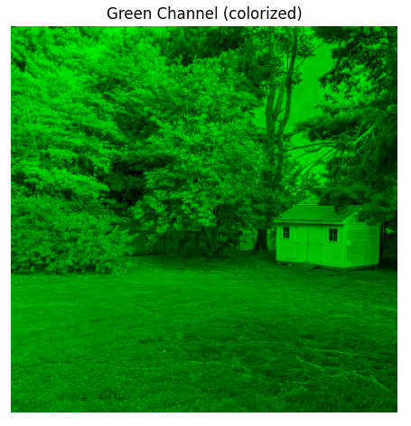
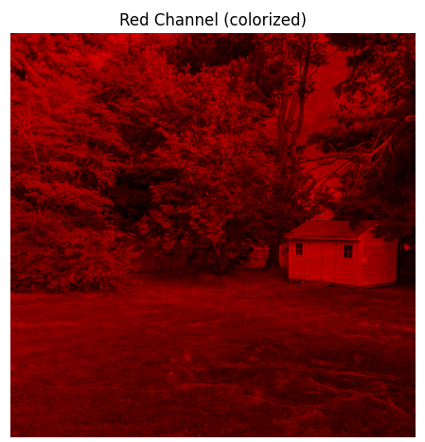
- Isolate the three RGB channels of A. Call these channel isolations RC, GC, and BC, respectively. Display these three images and save them as JPEGs at runtime.

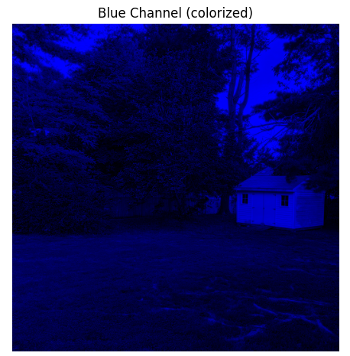

def split_channels_gray(A_rgb: np.ndarray) -> Tuple[np.ndarray, np.ndarray, np.ndarray]:
"""Return R, G, B as 2D grayscale arrays """
R = A_rgb[:, :, 0].astype(np.uint8)
G = A_rgb[:, :, 1].astype(np.uint8)
B = A_rgb[:, :, 2].astype(np.uint8)
return R, G, B
R_rgb, G_rgb, B_rgb = colorize_single_channel(R, G, B)
save_and_show_rgb(R_rgb, "Red Channel (colorized)", os.path.join(outputs, "RC_color.jpg"))
save_and_show_rgb(G_rgb, "Green Channel (colorized)", os.path.join(outputs, "GC_color.jpg"))
save_and_show_rgb(B_rgb, "Blue Channel (colorized)", os.path.join(outputs, "BC_color.jpg"))
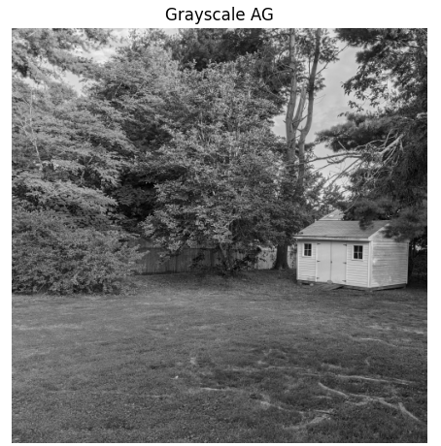
- Compute the grayscale image AG of A. Do this by explicitly taking the average of the three channels R,G, and B, at each pixel. Display AG at runtime.

def grayscale_average(R: np.ndarray, G: np.ndarray, B: np.ndarray) -> np.ndarray:
h, w = R.shape
AG = np.zeros((h, w), dtype=np.uint8)
for m in range(h):
for n in range(w):
AG[m, n] = (int(R[m, n]) + int(G[m, n]) + int(B[m, n])) // 3
return AG

AG = grayscale_average(R, G, B)
save_and_show_gray(AG, "Grayscale AG", os.path.join(outputs, "AG.jpg"))

4. Compute the histograms of the images RC, GC, BC, and AG, by explicitly scanning the image to access the value at pixel and counting the frequency of occurrence of each value, and display the histogram plots at runtime.
• To derive the histogram of each image, count the occurrences of each pixel brightness from 0 to 255.
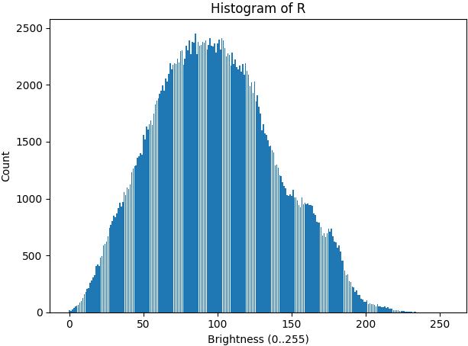

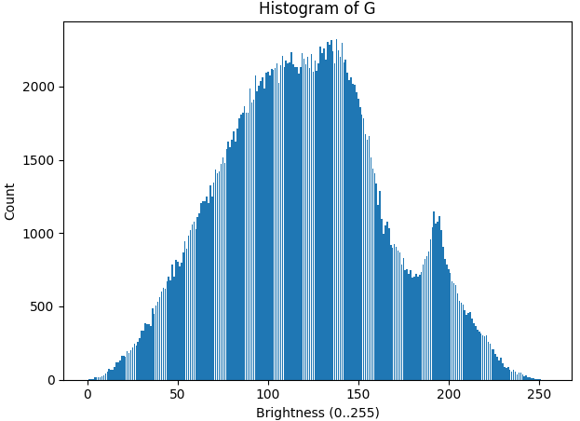

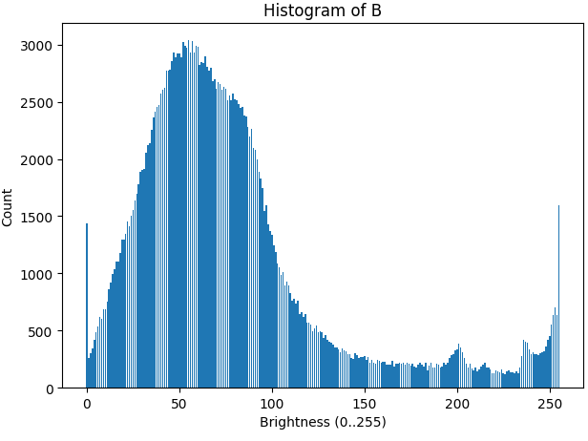

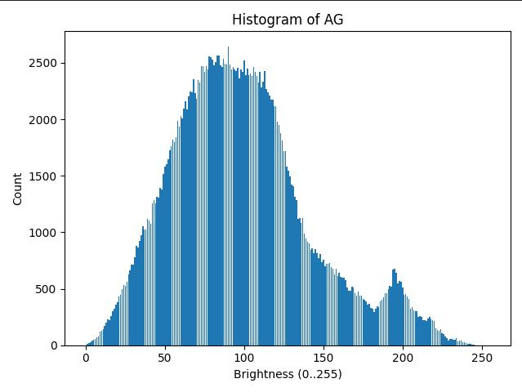

def histogram_256_by_scan(img_u8: np.ndarray) -> List[int]:
h, w = img_u8.shape
hist = [0]*256
for m in range(h):
for n in range(w):
hist[int(img_u8[m, n])] += 1
return hist

def show_hist(hist: List[int], title: str, outpath: str):
plt.figure()
plt.bar(range(256), hist)
plt.title(title)
plt.xlabel("Brightness (0..255)")
plt.ylabel("Count")
plt.tight_layout()
plt.savefig(outpath.replace(".png", ".jpg"), format="jpeg")
plt.show()
plt.close()

for arr, name in [(R,"R"),(G,"G"),(B,"B"),(AG,"AG")]:
hist = histogram_256_by_scan(arr)
show_hist(hist, f"Histogram of {name}", os.path.join(outputs, f"hist_{name}.png"))

5. Binarizing the image: Threshold the image AG to obtain a binary image AB. To do this, prompt the user to enter a threshold brightness TB as input at runtime (e.g. TB=100). You should access each pixel value and compute the new thresholded value.
• All pixels less than TB are assigned brightness 0 (black) and others are assigned brightness 255 (white). Display the output image AB at runtime.

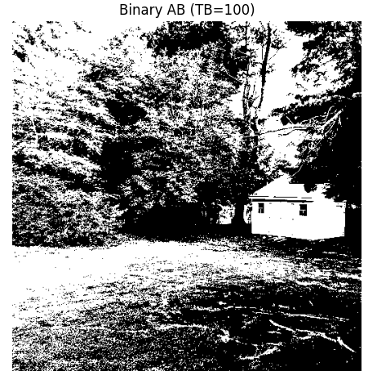

def threshold_binary(AG: np.ndarray, TB: int) -> np.ndarray:
h, w = AG.shape
AB = np.zeros((h, w), dtype=np.uint8)
for m in range(h):
for n in range(w):
AB[m, n] = 0 if int(AG[m, n]) < TB else 255
return AB

try:
TB = int(input("Enter TB (default 100): ").strip())
except:
TB = 100
AB = threshold_binary(AG, TB)
save_and_show_gray(AB, f"Binary AB (TB={TB})", os.path.join(outputs, f"AB_TB{TB}.jpg"))

6. Simple edge detection: Derive the edge image AE of AG as follows:

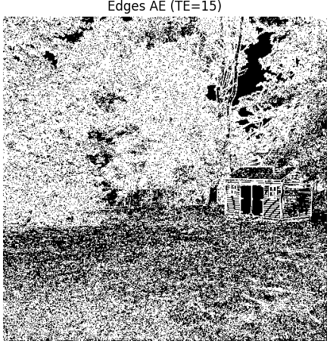

def simple_edges(AG: np.ndarray, TE: int) -> np.ndarray:
h, w = AG.shape
AE = np.zeros((h, w), dtype=np.uint8)
for m in range(h):
for n in range(w):
gx = (int(AG[m, n+1]) - int(AG[m, n])) if n < w-1 else 0
gy = (int(AG[m+1, n]) - int(AG[m, n])) if m < h-1 else 0
gm = math.sqrt(gx*gx + gy*gy)
AE[m, n] = 255 if gm > TE else 0
return AE

try:
TE = int(input("Enter TE (default 15): ").strip())
except:
TE = 15
AE = simple_edges(AG, TE)
save_and_show_gray(AE, f"Edges AE (TE={TE})", os.path.join(outputs, f"AE_TE{TE}.jpg"))

7. Image Pyramid: An image pyramid is a representation of an image where the original image size is recursively downsampled by a factor of 2 for each successive level of the pyramid.
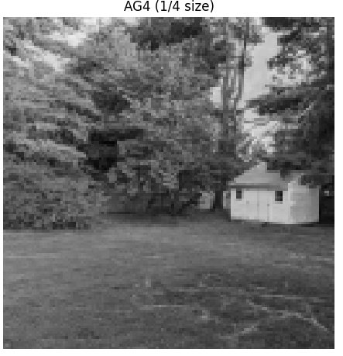
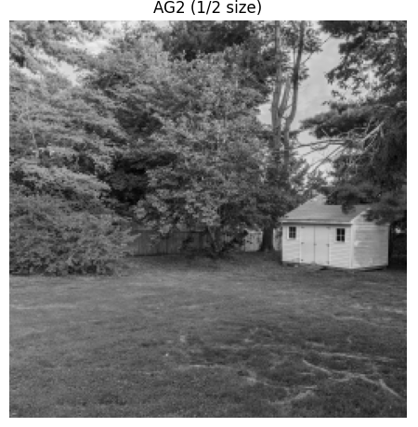

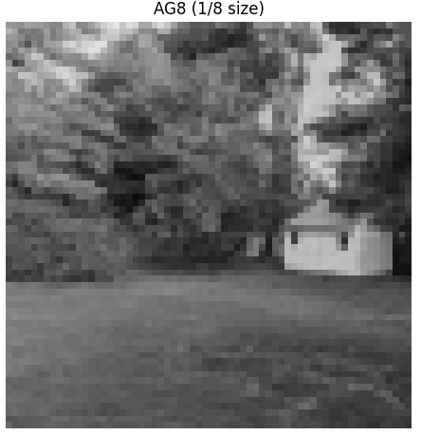

def downsample_2x2_avg(gray: np.ndarray) -> np.ndarray:
h, w = gray.shape
new_h, new_w = h // 2, w // 2
out = np.zeros((new_h, new_w), dtype=np.uint8)
for m in range(new_h):
for n in range(new_w):
r0, c0 = 2*m, 2*n
s = (int(gray[r0, c0]) +
int(gray[r0, c0+1]) +
int(gray[r0+1, c0]) +
int(gray[r0+1, c0+1]))
out[m, n] = s // 4
return out

AG2 = downsample_2x2_avg(AG); save_and_show_gray(AG2, "AG2 (1/2 size)", os.path.join(outputs, "AG2.jpg"))
AG4 = downsample_2x2_avg(AG2); save_and_show_gray(AG4, "AG4 (1/4 size)", os.path.join(outputs, "AG4.jpg"))
AG8 = downsample_2x2_avg(AG4); save_and_show_gray(AG8, "AG8 (1/8 size)", os.path.join(outputs, "AG8.jpg"))

AI Prompts used:

User: Can help me with a part of the code because the red, green, and blue channels don't give it color; it only gray-scales them instead.

ChatGPT: Here’s a drop-in replacement for your main.py that keeps your explicit-loops style but shows the R/G/B in color.

User: Save it as jpeg only

ChatGPT:

Right now your script saves both .jpg and .png because in save_and_show_gray and save_and_show_rgb, you’re calling plt.savefig(... .png) before saving the actual image as JPEG.

If you want JPEG only, here’s the minimal change:

Fix

In both save_and_show_gray and save_and_show_rgb, remove the plt.savefig(...) lines completely. That way, only the Image.fromarray(...).save(..., format="JPEG") line runs.

Here’s the corrected versions of those two functions

